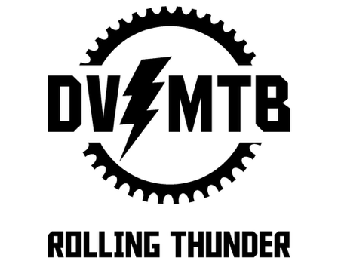
Cleaning Your Bike

- Night Before Every Ride
- Check tire pressure, should feel roughly as firm as an orange. Check with tire gauge regularly.
  - Rear tire pressure should be slightly higher than front, roughly 20 front, 23 rear. Exact pressure depends on rider weight, bike size, and preference.
  - Tire pressure calculator: https://www.wolftoothcomponents.com/pages/tire-pressure-calculator
- Make sure brakes, shifter, and shocks are functioning.
- Drop test - raise bike to shin height and drop, look/listen for any rattling or other noises indicating loose components.

- Regular Cleaning
- Clean bike every 3-4 rides, roughly once per week during the season. Clean more often in dusty, wet, or dirty conditions.
  - If gears or brakes are squeaking or not fully functioning, cleaning the bike is a good first step.
- Use degreaser every 2-3 cleans (deep clean every 3 or so cleans).
Important note on degreaser: Be careful to avoid brakes and seals for shocks. Getting degreaser on these parts will ruin seals and pads, lead to expensive repairs.
- When putting lube on, set hand on bracket and spin tire, adding lube in a line. Shift through cassette while pedaling to distribute lube. Start with quick link to ensure you lube entire chain.
- Don’t use high pressure spray on bike when washing.

3) Regular Maintenance
Tubeless tires
- Sealant every 3 months, 6-8 weeks in summer.
- Put full mini jar of sealant in each tire.
- If needing to add a tube due to flat, will need to have it resealed.
- Video instructions: https://youtu.be/hpeGQ9kZMPg?feature=shared

Shocks
- Check regularly with pump - look at manufacturer page for specific shocks for instructions.
- Have shocks rebuilt annually when riding frequently.

Cleaning supplies
- Cleaning spray, examples are Muc-off, Pedro’s, Finish Line, or Dawn foaming dish soap.
  - Important note: make sure cleaning supplies and degreasers do not get on the brakes or shock seals. This will lead to expensive repairs.
- Rags.
- Toothbrush or cleaning tool. Recommend using a different one than for brushing your teeth.
- Bike lube such as Finish Line, Muc-off.
- If using tubeless tires, need sealant refill such as Stans or Orange Seal.

Discounts
- The Arizona Cycling Association (which DV MTB is part of) offers discounts on a variety of products to registered riders: https://arizonacycling.org/member-benefits/
- The DV MTB bike shop sponsors also offer discounts and priority service.
  - As of 2026, the team sponsors are Emigos and Landis Cyclery

Resources
- Park Tools website: https://www.parktool.com/en-us/blog/repair-help

